Software Requirements Specification

for

<EDUTECH Website Project>

Version 1.0 approved  
  
Prepared by

|  |  |
| --- | --- |
| **Name** | **PRN** |
| Kumar Ankur | 230340320048 |
| Abhinav Verma | 230340320003 |
| Pranita Kushalchand Bondarde | 230340520063 |
| Ashish Ashruba Autade | 230340320019 |
| Bhagyashree Prakash Bhamare | 230340520020 |
| Suraj Dnyaneshwar Kawale | 230340520106 |

Organization  
  
CDAC Mumbai Final Project Team 05

Table of Contents

Table of Contents ii

Revision History ii

1. Introduction 3

1.1 Purpose 3

1.2 Scope 3

1.3 Definitions, Acronyms, and Abbreviations 4

1.4 References 5

1.5 Overview 5

2. Overall Description 6

2.1 Product Perspective 6

2.2 Product Functions 7

2.3 User Classes and Characteristics 7

2.4 Operating Environment 7

2.5 Design and Implementation Constraints 7

2.6 User Documentation 8

2.7 Assumptions and Dependencies 8

3. External Interface Requirements 8

3.1 User Interfaces 8

3.2 Hardware Interfaces 9

3.3 Software Interfaces 9

3.4 Communications Interfaces 9

4. System Features 10

4.1 User Authentication 10

4.2 User Authorization 10  
4.3 Course Management 11

4.4 Quiz Management 11

4.5 Assignment Management 12

4.6 Certificate Management 13

4.7 Notification Management 13

4.8 Admin Functions 13

5. Other Nonfunctional Requirements 14

5.1 Performance Requirements 14

5.2 Safety Requirements 14

5.3 Security Requirements 14

5.4 Software Quality Attributes 15

6. Other Requirements 15

6.1 Database Requirements 15

6.2 Legal and Compliance Requirements 16

Appendix A: Analysis Models 17

Appendix B: To Be Determined List

Revision History

|  |  |  |  |
| --- | --- | --- | --- |
| **Name** | **Date** | **Reason For Changes** | **Version** |
|  |  |  |  |
|  |  |  |  |

**1. Introduction**

**1.1 Purpose**

The purpose of this document is to provide a comprehensive specification for the Edutech website project. It includes detailed requirements, architecture, design, features, interfaces, workflows, and other relevant aspects of the system. By defining the scope, user roles, functional requirements, and non-functional attributes, this document aims to guide the development process and ensure the successful realization of the project objectives.

**1.2 Scope**

The scope of the Edutech website project defines the boundaries, objectives, and functionalities that the platform will encompass. It outlines the extent to which the project will cater to the needs of users and the features it will offer to enhance their educational experience. The scope serves as a roadmap that guides the project's development, ensuring that the resulting platform meets the intended goals and user expectations.

The scope of the Edutech website project includes:

* **Educational** **Platform**: The project aims to develop a comprehensive online educational platform that accommodates students, faculty members, and administrators. The platform's primary purpose is to facilitate efficient learning, interaction, and management within an educational context.
* **User** **Roles** **and** **Interactions**: The platform will cater to three main user roles: Administrators, Faculty, and Students. Each user role will have distinct functionalities and privileges tailored to their responsibilities. Administrators will oversee the entire system, Faculty will manage courses and assessments, and Students will enroll in courses and engage with learning materials.
* **User Management**: The system will provide user registration and login mechanisms, ensuring secure access to the platform. Users will be able to create accounts, log in with credentials, and maintain profile information.
* **Course Management**: The platform will support the creation, management, and enrollment of courses. Faculty members will be able to create courses, manage course materials, and students will be able to enroll in courses.
* **Assessment Management**: The platform will enable the creation, submission, and grading of quizzes and assignments. Faculty members can create assessments, set deadlines, receive student submissions, and provide grades.
* **Certificate Issuance**: Upon successful completion of courses, students will be eligible to receive certificates. The platform will automate the process of generating and issuing certificates to qualified students.
* **Notifications**: The system will facilitate communication through notifications. Users will receive timely updates, reminders about course deadlines, assessment schedules, and other relevant information.
* **Admin Oversight**: Administrators will have access to an admin dashboard where they can manage users, monitor system activities, and configure system settings.
* **Performance and Security**: The scope includes ensuring that the platform is responsive, scalable, and secure. Measures will be taken to prevent unauthorized access, data breaches, and system vulnerabilities.
* **Documentation and Support**: The scope encompasses the creation of user manuals, video tutorials, and contextual help to assist users in navigating and utilizing the platform effectively.

**1.3 Definitions, Acronyms, and Abbreviations**

In this section, key terms, acronyms, and abbreviations are defined to ensure clarity and uniform understanding throughout the document and the project's development phases.

* **Admin**: An abbreviation for "Administrator," referring to users with administrative privileges and control over the entire system.
* **DBMS**: Short for "Database Management System," which is a software application used for creating, managing, and interacting with databases.
* **ERD**: Stands for "Entity Relationship Diagram," a visual representation used to model the relationships between entities (tables) in a database.
* **Frontend**: The user interface and components that users interact with directly. It includes web pages, forms, and visual elements.
* **Backend**: The server-side logic, processes, and functionalities that power the frontend and manage data interactions.
* **UI**: Abbreviation for "User Interface," encompassing the visual and interactive elements of the system that users engage with.
* **UX**: Short for "User Experience," focusing on how users interact with and perceive the system, emphasizing usability and satisfaction.
* **API**: Stands for "Application Programming Interface," providing a set of rules and protocols for building and interacting with software applications.
* **TLS**: Abbreviation for "Transport Layer Security," a cryptographic protocol ensuring secure data transmission over a network.
* **SMTP**: Stands for "Simple Mail Transfer Protocol," used for sending emails between servers.
* **IMAP**: Abbreviation for "Internet Message Access Protocol," used for retrieving emails from a server.
* **HTTP**: Stands for "Hypertext Transfer Protocol," the foundation of data communication on the World Wide Web.
* **HTTPS**: An extension of HTTP, where data is encrypted for secure communication.
* **React**: A JavaScript library for building user interfaces, providing a component-based approach for efficient frontend development.
* **Java (Spring Boot)**: A widely used programming language and framework for developing robust and scalable backend applications.
* **MySQL/SQL Server**: Relational Database Management Systems used for data storage and retrieval in the project.

**1.4 References**

• <https://spring.io/>

• <https://www.javascript.com/>

• <https://developer.mozilla.org/en-US/docs/Web/JavaScript>

• <https://en.wikipedia.org/wiki/Model%E2%80%93view%E2%80%93controller>

**1.5 Overview**

This Software Requirements Specification (SRS) document is organized into sections that provide detailed insights into the Edutech website project. These sections cover aspects such as system architecture, user interfaces, functionality, database design, security measures, testing strategies, deployment, and maintenance. Each section contributes to a holistic understanding of the project's scope and objectives.

**2. Overall Description**

**2.1 Product Perspective**

The product perspective provides an insightful overview of the Edutech website project in relation to its environment, stakeholders, and its place in the broader educational technology landscape.

The Edutech website is designed to be a standalone educational platform that caters to the needs of students, faculty members, and administrators within an educational institution or organization. It offers a cohesive and user-centric solution to enhance the educational experience by providing a range of features that streamline course management, assessment, and engagement.

**Interactions**:

**Students**: The platform directly interacts with students, providing them access to course materials, quizzes, assignments, and certificates. It empowers students to engage with the learning process, monitor their progress, and receive valuable feedback.

**Faculty Members**: Faculty members play a vital role in managing courses, creating assessments, and interacting with students. The platform provides tools to streamline their teaching efforts and efficiently evaluate student performance.

**Administrators**: Administrators oversee the entire platform, managing user accounts, courses, and system configurations. They monitor activities, ensure compliance with policies, and maintain the overall integrity of the system.

**Integration with Educational Environment**:

The Edutech website is designed to seamlessly integrate with educational environments, complementing traditional teaching methodologies with modern technology-driven tools. It enables educators to enhance the learning experience, promote student engagement, and streamline administrative tasks.

**Industry and Educational Landscape**:

The product perspective places the Edutech website within the broader context of the educational technology landscape. It acknowledges the increasing demand for digital learning solutions and highlights the platform's potential to contribute to the evolving educational ecosystem.

**Long-Term Viability**:

The Edutech website is not isolated; it has the potential for future enhancements and integrations as the educational landscape evolves. The platform's design and architecture allow for scalability, ensuring that it can adapt to emerging trends and technologies.

**2.2 Product Functions**

The platform's key functions include:

* **User Management**: Registration, login, and user profiles.
* **Course Management**: Creation, enrollment, and management of courses.
* **Quiz and Assignment Management**: Creation, submission, and grading.
* **Certificate Issuance**: Issuing certificates upon successful course completion.
* **Notifications**: Sending updates, reminders, and event-triggered notifications.
* **Admin Dashboard**: A dedicated interface for administrators to oversee system operations.

**2.3 User Classes and Characteristics**

* **Admins**: Responsible for system-wide management, including users, courses, and configuration.
* **Faculty**: Manage courses, quizzes, assignments, and interact with students.
* **Students**: Enroll in courses, take quizzes, submit assignments, and access learning materials.

**2.4 Operating Environment**

The Edutech website will operate in the following environment:

**Frontend**: Developed using React, a JavaScript library, for dynamic and interactive user interfaces.

**Backend**: Implemented using Java (Spring Boot) for robust server-side logic execution and API development.

**DBMS**: Utilizing MySQL or SQL Server to store and retrieve data efficiently.

**Browsers**: Support for popular browsers like Chrome, Firefox, and Safari.

**2.5 Design and Implementation Constraints**

The development process will adhere to the following constraints:

**Regulatory** **Compliance**: Adherence to educational regulations, ensuring a secure and ethical environment.

**Security** **Measures**: Implementation of security protocols to safeguard user data.

**Timely** **Delivery**: Meeting project milestones and ensuring timely deployment.

**2.6 User Documentation**

User documentation mainly comprises of Help Menu of application. It will give all the minute details about the project, if any user has any query about any module or functionality, one can refer it and see how to operate the application. This report is the complete documentation of our project. It gives complete details about the project, its functionality, users, software used, hardware requirement, environment and so on.

**2.7 Assumptions and Dependencies**

* Users possess basic computer and web proficiency.
* Users have reliable internet connectivity.
* The system relies on hosting and server dependencies for optimal performance.

**Server and Hosting Dependencies**: The system's functionality relies on the availability and reliability of the hosting environment, ensuring continuous access to the platform.

**Browser** **Compatibility**: Users are assumed to use modern web browsers like Chrome, Firefox, and Safari, with reliable internet connectivity for optimal performance and usability.

**3. External Interface Requirements**

**3.1 User Interfaces**

- Registration and login pages

- Student dashboard

- Faculty dashboard

- Admin dashboard

- Course details page

- Quiz/assignment submission pages

- Payment page

- Certificate page

**3.2 Hardware Interfaces**

In the Edutech website project, hardware interfaces are like bridges between users and the platform. Devices such as computers, laptops, tablets, and phones are the tools people use to access the platform. Things like keyboards, screens, and mouse help users give commands and see what's happening. It's important that the platform looks good and works well on all kinds of devices, so designers make sure it can adjust to different screen sizes. For phones, which people use with their fingers, the platform will be made easy to use by tapping and swiping. These hardware interfaces make it possible for everyone to use the platform smoothly, no matter what device they're using.

**3.3 Software Interfaces**

**Operating Systems**: Windows, MacOS, Linux.

**Browsers**: Chrome, Firefox, Safari.

**Backend**: Java (Spring Boot) for server-side logic.

**DBMS**: MySQL or SQL Server for data storage and retrieval.

**3.4 Communications Interfaces**

**HTTP/HTTPS Protocols**: For secure data transmission between clients and the server.

**SMTP/IMAP**: Used for sending and receiving email notifications.

**Web Service APIs**: If applicable, for external integrations.

**4. System Features**

**4.1 User Authentication**

User authentication is a fundamental aspect of the Edutech website's functionality, ensuring that only authorized users gain access to the platform while safeguarding sensitive information. This process involves validating the identity of users who wish to log in, register, or access certain features.

**User Registration**: The user registration process enables new users to create accounts by providing necessary details such as a unique username, a secure password, and relevant personal information. This information is securely stored in the database to facilitate future logins and personalized experiences.

**Login Mechanism**: The login mechanism allows users who have registered to access their accounts. Users input their registered credentials, typically a username and password. The platform verifies these credentials against the stored data and grants access if they match.

**4.2 User Authorization**

User authorization is a critical aspect of the Edutech website's functionality, defining what actions and resources each user role (Admin, Faculty, Student) can access and interact with once they have been authenticated. This process ensures that users have appropriate permissions to carry out specific tasks based on their roles and responsibilities within the platform.

**Role-Based Access Control**: The platform employs role-based access control (RBAC) to categorize users into predefined roles. Each role is associated with a set of permissions that dictate what actions and features users can access. For instance, Administrators have broader access to system settings, while Faculty members can manage courses and assessments, and Students can enroll in courses and access learning materials.

**Admin Privileges**: Administrators, as the highest-level role, have comprehensive access to all administrative functions, including user management, course creation, assessment management, and overall system configuration.

**Faculty Privileges**: Faculty members can manage the courses they are associated with. They can create and edit course content, set up assessments, grade submissions, and monitor student performance.

**Student Privileges**: Students primarily have access to enrolled courses, enabling them to view course materials, participate in quizzes, submit assignments, and track their progress.

**4.3 Course Management**

Course management is a pivotal feature within the Edutech website, empowering Faculty members and Administrators to efficiently create, organize, and oversee courses, which serve as the backbone of the educational experience.

**Course Creation**: Faculty members, with the appropriate privileges, can create new courses by providing essential information such as course name, description, and objectives. They can set prerequisites, assign a faculty member as the instructor, and determine the course's visibility.

**Course Organization**: Once created, courses can be organized with different modules, lessons, and resources. Faculty members can structure the curriculum by adding modules that contain lessons, quizzes, assignments, and additional learning materials.

**Learning Materials**: Learning materials such as text documents, presentations, videos, and images can be uploaded and attached to specific lessons. This enables students to access relevant content directly within the platform.

**Enrollment Management**: Faculty members and Administrators can manage course enrollment, approving or disapproving student requests to join the course. This control ensures that students are appropriately assigned to courses.

**Course Updates**: Faculty members can update course content, add new lessons, or modify existing materials as the course progresses. This ensures that courses remain up-to-date and aligned with learning objectives.

**Student Interaction**: Students can engage with course content, submit assignments, and participate in quizzes. Their interactions are logged and can be monitored by Faculty members for evaluation.

**Administrative Oversight**: Administrators have a holistic view of all courses and their activities. They can intervene when necessary, manage course details, and ensure smooth operation across the platform.

**4.4 Quiz Management**

Quiz management is a pivotal feature within the Edutech website, enabling Faculty members to create, administer, and assess quizzes that enhance the learning experience and measure student understanding.

**Quiz Creation**: Faculty members with appropriate permissions can create quizzes by defining quiz details such as title, description, duration, and the number of questions. They can also determine whether the quiz is graded and set passing criteria.

**Question Bank**: Quizzes can draw from a question bank, allowing Faculty members to assemble quizzes with diverse question types such as multiple-choice, true/false, and short-answer questions. This variety ensures a comprehensive assessment of student knowledge.

**Question Creation**: Faculty members can add questions to the question bank, categorizing them based on topics or difficulty levels. This repository facilitates the reuse of questions in different quizzes and courses.

**Assessment Criteria**: For graded quizzes, Faculty members can set scoring criteria for each question and define the overall grading structure. They can also decide whether to reveal correct answers after the quiz is completed.

**4.5 Assignment Management**

Assignment management is a crucial component of the Edutech website, providing a platform for Faculty members to assign tasks, collect submissions, and provide feedback to students, thereby fostering active learning and assessment.

**Assignment Creation**: Faculty members, with the appropriate privileges, can create assignments by specifying assignment details such as title, description, due date, and any specific instructions or requirements.

**Submission Channels**: Students can submit their assignments through designated submission channels, such as file uploads or text entry fields. This flexibility accommodates different types of assignments, from essays to code projects.

**Assignment Visibility**: Faculty members can control the visibility of assignments, making them accessible to students within the designated time frame. This prevents late submissions and ensures a fair assessment process.

**Assignment Tracking**: The platform tracks submission dates and times, enabling Faculty members to monitor student adherence to deadlines and assess time management skills.

**Grading Criteria**: Faculty members can define grading criteria for assignments, detailing the components on which students will be evaluated. This ensures transparency in assessment.

**Plagiarism Detection**: The platform may integrate with plagiarism detection tools to ensure academic integrity. This feature identifies similarities between submitted assignments and existing content, deterring plagiarism.

**Re-Submission**: Faculty members can allow re-submission of assignments within specified limits, encouraging iterative improvement and learning from mistakes.

**4.6 Certificate Management**

Certificate management is a significant feature within the Edutech website, providing an incentive for student engagement and recognizing their achievements upon successful completion of courses and assessments.

**Certificate Criteria**: Certificates are issued based on predefined criteria, including achieving a passing score in quizzes and assignments. This criteria ensures that certificates are awarded only to students who demonstrate sufficient understanding and effort.

**Passing Threshold**: The platform establishes a passing threshold for quizzes and assignments, indicating the minimum score required to qualify for a certificate. This ensures that certificates reflect a certain level of proficiency.

**Quiz Performance**: Students must achieve a passing score in quizzes, demonstrating their grasp of course content. Quizzes serve as checkpoints for assessing comprehension and retention.

**Assignment Evaluation**: Additionally, students must earn a passing grade in assignments, reflecting their ability to apply knowledge and skills in practical scenarios.

**Certificate Generation**: Once students meet the certificate criteria, the platform automatically generates certificates. These certificates can be downloaded, printed, and shared as digital credentials.

**Certificate Design**: The design of certificates can be customized to align with the platform's branding, enhancing their aesthetic appeal and credibility.

**4.7 Notification Management\***

Notification management is a pivotal component of the Edutech website, facilitating effective communication and engagement between users and the platform through timely updates and reminders.

**4.8 Admin Functions**

Admin functions form the backbone of the Edutech website's operational management, providing Administrators with tools to oversee the platform, manage users, maintain courses, and ensure smooth functioning.

**User Management**: Administrators can manage user accounts, including registration approval, profile updates, and account deactivation if necessary.

**Course Oversight**: Administrators have a comprehensive view of all courses and their status. They can intervene in case of issues, ensure course quality, and handle exceptional situations.

**Course Creation**: Administrators have the capability to create new courses, setting up initial parameters and assigning instructors as necessary.

**User Support**: Administrators provide support to users by addressing queries, troubleshooting issues, and ensuring a positive user experience.

**5. Other Nonfunctional Requirements**

**5.1 Performance Requirements**

Performance requirements are essential to ensure that the Edutech website operates smoothly, providing users with a responsive and seamless experience. Pages should load within a maximum of 5 seconds to maintain user engagement. The platform should be able to handle concurrent users up to 1000 without significant slowdowns. Additionally, the system should be capable of handling a minimum of 100 requests per minute to ensure efficient interaction between users and the platform.

**5.2 Safety Requirements**

Safety requirements focus on preventing unauthorized access, protecting user data, and ensuring the integrity of the platform. Measures to prevent SQL injection attacks are crucial to safeguard the database and prevent data breaches. Input data validation is vital to eliminate potential security vulnerabilities. Sensitive data, such as passwords and personal information, should be encrypted to prevent unauthorized access. These safety measures ensure user trust and data security.

**5.3 Security Requirements**

Security requirements encompass a range of measures to maintain the platform's security. Password salting and hashing enhance password security by making it difficult for attackers to decipher passwords. Role-based access control restricts users' access to specific features based on their roles, preventing unauthorized actions. Regular security audits and assessments help identify vulnerabilities and mitigate potential risks. By incorporating these security measures, the Edutech website ensures a secure and protected environment for users and their data.

**5.4 Software Quality Attributes**

Software quality attributes are vital to ensure that the Edutech website provides a user-friendly, reliable, and maintainable platform. High usability ensures that users can easily navigate the interface and access features without confusion. A modular design allows for flexibility and scalability, enabling future enhancements and modifications. Maintainability ensures that the codebase is organized and documented, simplifying updates and bug fixes. Reliability guarantees consistent performance and availability, reducing downtime. Portability allows the platform to run smoothly on different devices and operating systems, catering to a diverse user base. These software quality attributes collectively contribute to a positive user experience and a well-functioning platform.

**Usability**: The user interfaces should be intuitive and user-friendly.

**Maintainability**: The codebase should be well-structured and easily maintainable.

**Reliability**: The system should provide consistent and reliable performance.

**Portability**: The system should function smoothly across different platforms and browsers.

**6. Other Requirements**

**6.1 Database Requirements**

Database requirements are fundamental to ensuring efficient data management and storage within the Edutech website. The chosen database system, such as MySQL or SQL Server, should be capable of handling concurrent read and write operations without performance degradation. The database schema should reflect the relationships between entities, including users, courses, quizzes, assignments, and certificates. Proper indexing of tables enhances data retrieval speed, especially for frequently accessed data like user profiles and course details.

**User Data Storage**: The database should securely store user information, including usernames, hashed passwords, roles, and personal details. Encryption and proper data handling techniques should be employed to protect sensitive data.

**Course and Content Management**: Course-related information such as course names, descriptions, instructor details, and associated resources should be organized within the database. Additionally, quiz and assignment details, including questions, submissions, and grades, should be efficiently stored and retrievable.

**Notification Records**: The database should maintain records of notifications sent to users, allowing for tracking and auditing of communication.

**Certificate Records**: Certificate issuance records, including details of awarded certificates, issuance dates, and recipients, should be stored for verification purposes.

**Scalability**: The database design should accommodate future growth and scaling of the platform, ensuring that it can handle increased user activities and data volumes.

**Data Integrity and Consistency**: Data validation mechanisms and proper constraints should be implemented to ensure data integrity and consistency.

**6.2 Compliance and Legal Requirements**

Compliance and legal requirements are crucial to ensure that the Edutech website operates within established regulations and safeguards user rights. This includes adherence to applicable educational laws and regulations to ensure the platform's content and activities align with educational standards. A privacy policy is essential to inform users about data collection, storage, and usage practices. Terms of use clarify user responsibilities, intellectual property rights, and acceptable behavior on the platform. By meeting compliance and legal requirements, the Edutech website establishes a trustworthy and transparent environment for users.

**7. Appendix**

**7.1 ERD Diagram**

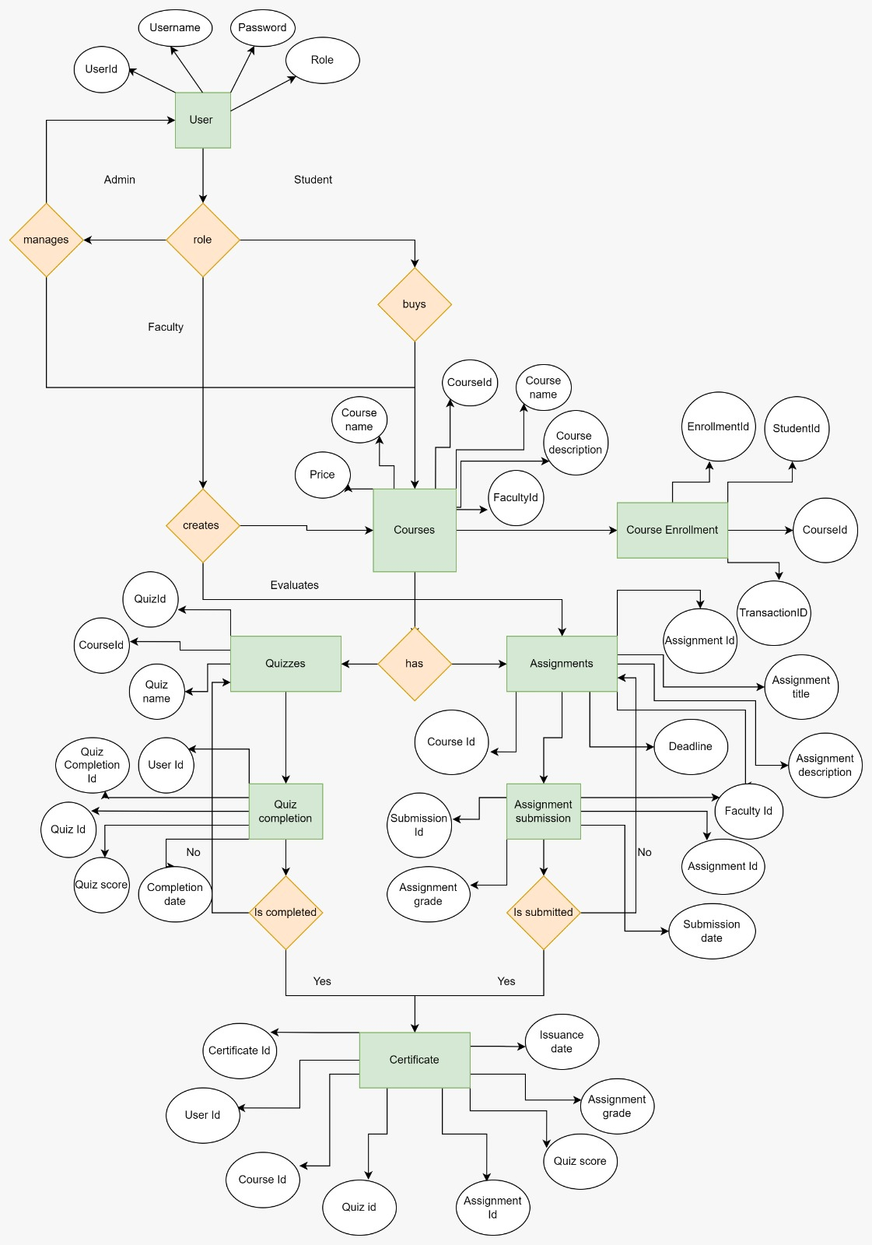

**7.2 Database Schema**

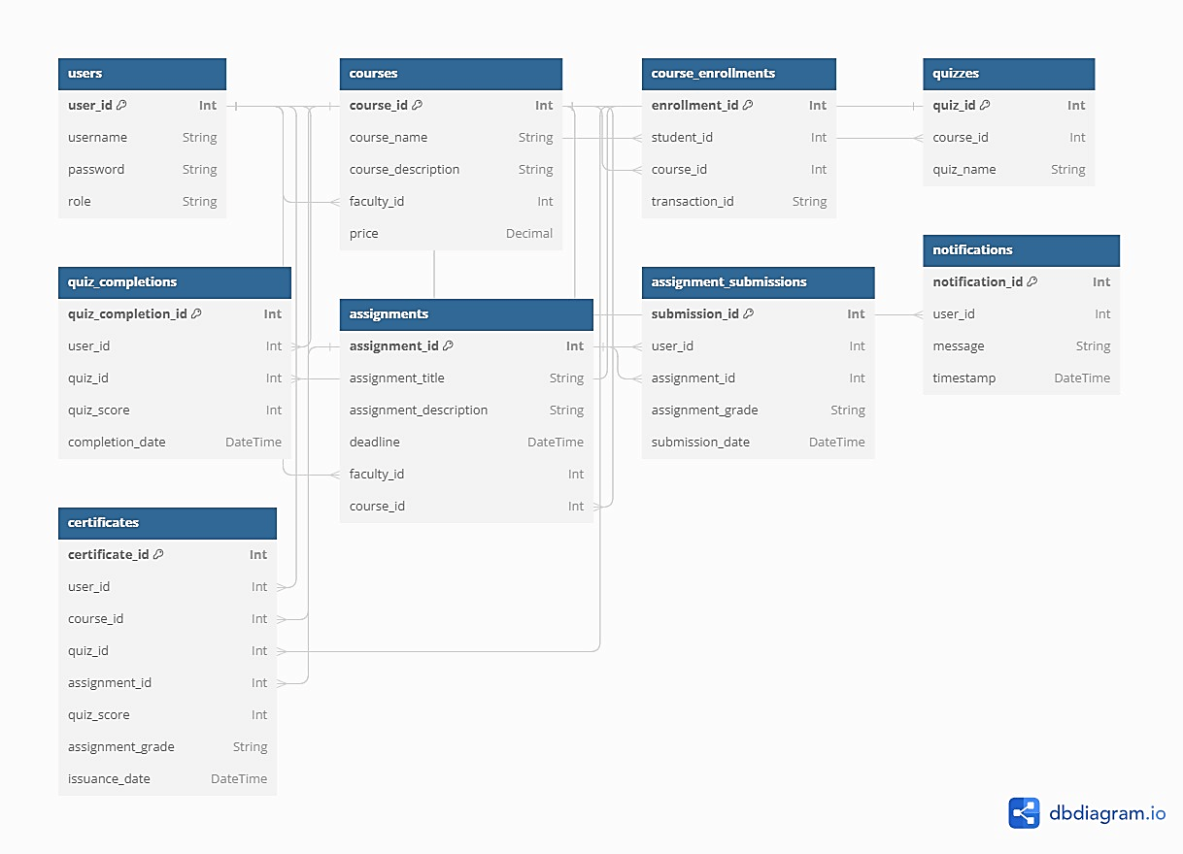

**7.2 Use Case Diagrams**

**a. Admin**

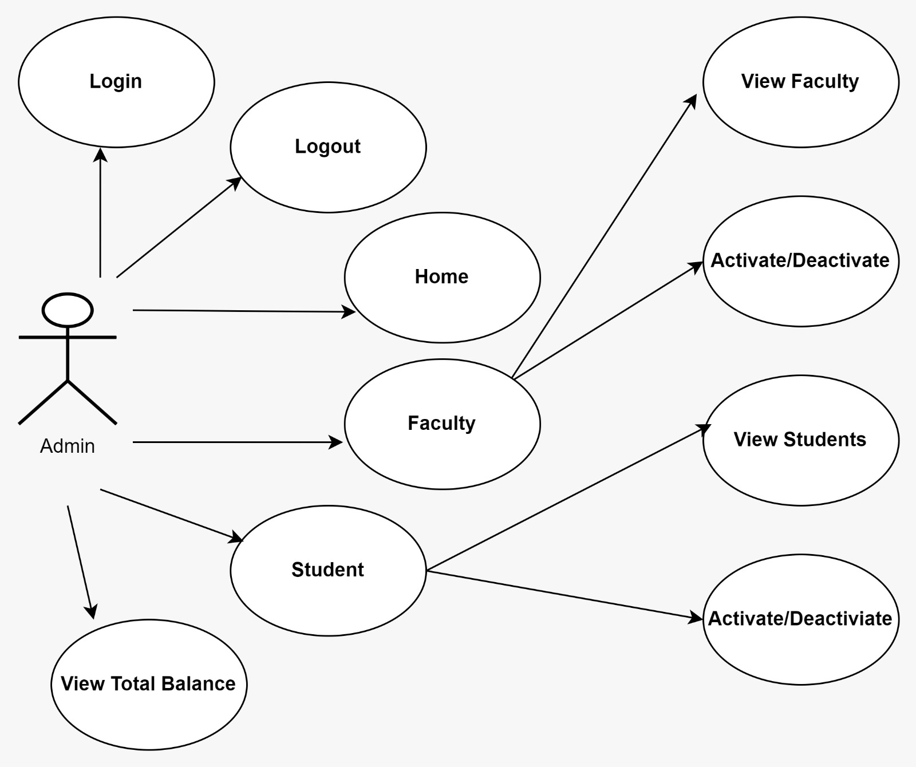

**b. Student** 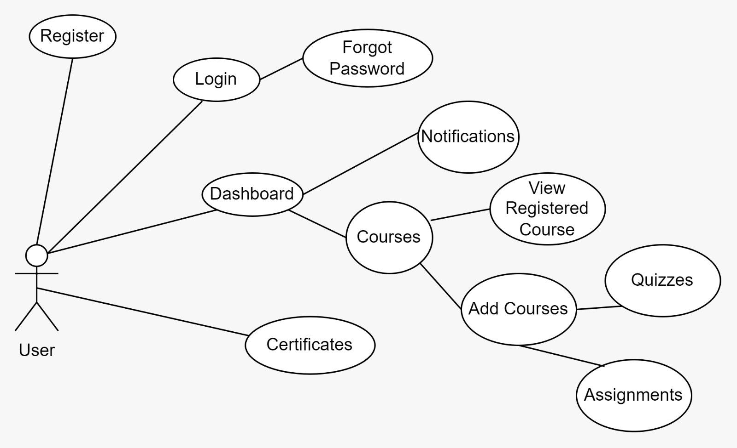

**c. Faculty** 